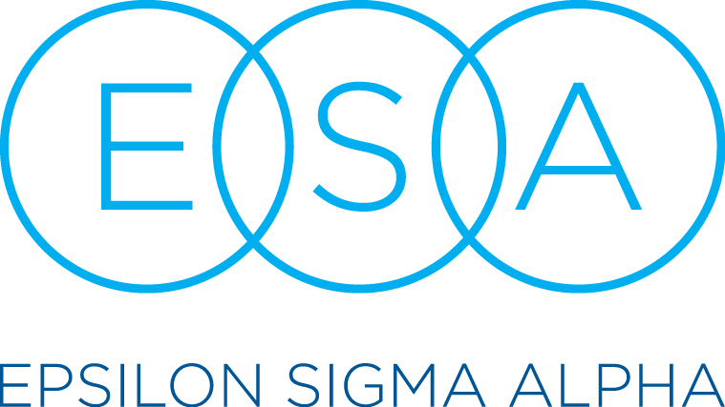
“Imagination Briefings”
SERC Newsletter
September 2022
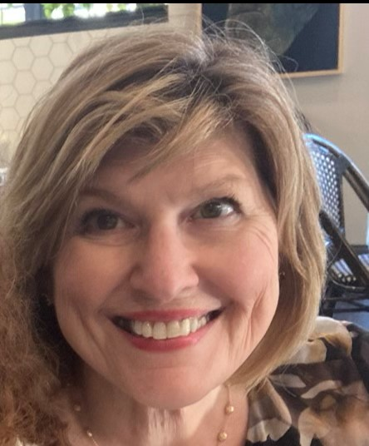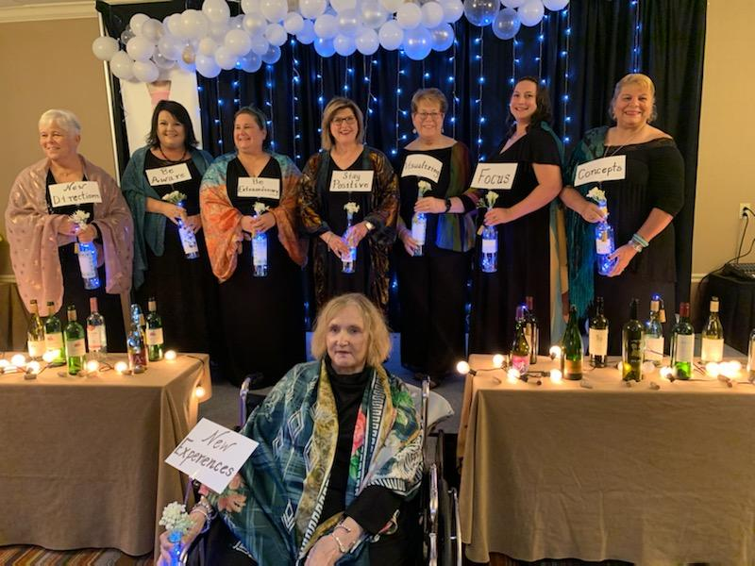
Terri Sayre, President

Happy Early Fall Everyone!!!

And just like that…summer is finally over! Fall is just beginning and suddenly you know it’s time to trust your imagination and start something new!

What is your favorite part about the Fall Season? Fall is definitely my all-time favorite season! My favorites are going to the Smokies in the fall to see the beautiful leaves that put on a magnificent show! And I must admit, I love doing the roadside stop ‘n shops along the way to the mountains! Good way to pick up unique gifts!

While I have so many great memories of past autumns, one of my absolute favorites is the SERC Conference!! I love that it takes place in the fall season, and that the weather is usually wonderful! This year, the conference is in Orlando on November 4th and 5th and I’m very honored and excited to preside over the meeting and wind up our year as your SERC President.

Our IC Convention in Indianapolis was emotional as well as uplifting, enlightening, and quite frankly pretty awesome! A fun time was priority, and it was definitely accomplished. Your newly elected IC Executive Board members are Denise Holdaway President, Brenda Meyers 1st Vice President, Lynda Edwards 2nd Vice President, Celeste Webb Treasurer, Angela Butenschoen Recording Secretary, Margaret Kramer Parliamentarian, Patricia Gale Workshop Coordinator, Sandy Fletcher Corresponding Secretary and LeAnn Wray IC Past President. I believe most, maybe all of these folks are coming to SERC!

I cannot begin to express how important ESA is to me personally, and I am certain that is a common feeling amongst all ESA members. I know that each of us has some kind of personal experience we could share where being in ESA has touched us deeply. I believe most of us see ESA as family, and we truly are! And we must think about the future of this family and keep it growing and going! We must focus on membership so that we can continue to have community and camaraderie that extends to the very soul of each of us, knowing we are a family that looks out for each other as well as the organizations we support. This should be a priority in every chapter and always on the minds of every member so that we can accomplish this mission. Always ask someone you know if they are interestein being a part of the most prestigious philanthropic and service organization in the country! Tell them it’s ESA, tell them what we do and then say, “I am so very proud to extend this membership invitation to you!” Make that person feel very special and it will come back to you tenfold! And here’s the good news, every word you say is absolutely 100% truth with loads of documentation to back you up! Please give this a try. Go for it and see what happens!

Hey…have you registered yet for the SERC Conference in Orlando? I hear things are really hopping in Orlando! The flamingos down there are going to be beautiful and amazingly entertaining! I was informed by the Convention Committee that it will be “so much FUN!’ So, I’m thinking we should all come prepared for a fabulous experience at the SERC Conference! We are planning a Thursday evening dinner night out and will have the details on cost and location very soon, and I will be sure everyone knows so we can get a fairly accurate count. Friday morning there will be a Sun Rail Train ride that will take you to Winter Park, FL and your choice of either A) shopping the Park Avenue specialty shops with award winning eateries and a tour of Tiffany exhibits at the Morse Museum, or B) a very cool Scenic Boat Tour that takes you through the canals of historic Winter Park, breathtaking views of sprawling estates, Florida’s wildlife and beautiful subtropical flowers. Lunch is on your own at one of the many great restaurants to choose from, and the price for either of these selections is only $20. This is offered for Friday November 4th and would last from 8:30 am to 3:00 pm with some, but not much walking. The registration form for the SERC Conference and the tours are on the SERC website as well as at the end of this SERCH Newsletter!

In closing, I would like to share the following from author Nora Roberts with y’all because I believe it applies to so many obstacles we face. “If you don’t go after what you want, you’ll never have it. If you don’t ask, the answer is always no. If you don’t step forward, you’re always in the same place!” Let’s step up in ESA, increase our membership and take another step and get on committees and run for an office. I can tell you for a fact it’s the best way to really get to know your ESA family even better! See you in Orlando!
Prayers out for the members in Hurricane Ian’s path.
Terri Sayre, SERC President 2021-2022, TLSAYRE@COX.NET 504-231-6145
From your Corresponding Secretary:

This is a post IAN notice: Our scheduled Thursday night dinner has been cancelled by the host restaurant. We are sorry we cannot schedule another Thursday night dinner for the early arrives at this time. I am posting, at the end of this newsletter, a list of the close by restaurants which could be open for you to investigate on your own that night. Sorry for any inconvenience but the hotel has verified that our conference is still on. Hope to see you in Orlando!

Alice Buss, Corresponding Secretary

From the Convention Finance Project:

Good Afternoon Ladies!

Convention is almost here!! For the Finance Project, Sandy and I are asking that each state bring/provide a purse/bag with $100 to $200 in gift cards for an auction. There will also be a 50/50 drawing.
We are hoping that we can pad our SERC funds with a good auction and purses/bags are not too difficult to carry home for those of us who will be flying to the meeting. I can't wait to see everyone!

Casey Hoffman
Mississippi
601-551-9525

TO State Presidents

Dear SERC State Presidents:

ESA Florida State Council is looking forward to seeing you and your membership at the 2022 SERC Convention November 4-5. Many of you have already registered, meeting the October 7, 2022 deadline. We hope many more of you will join us for what we expect to be a great time. It looks like President Terri is going to make sure we have a lot of FUN!!

In addition to the good times of convention ESA Florida State Council has arranged for more adventure. The attachment below provides information on two unique experiences for you to choose from. Please note both of these tours are on November 4th. The deadline to sign up for the excursion of your choice is October 7th.

Please send this information to your state membership so that the members can get their reservations in by the deadline of October 7th. I

Should you have any questions please reach out to Karlene Beville at bevillek@gmail.com or 407-414-3462 or Joy Lehnert at joy.lehnert@yahoo.com or 402-690-7720.

See you soon!

Thank you.

Verna Cornell, Co-Chair
Christine Bishop, Co-Chair
Joy Lehnert, Secretary/Treasurer
2022 SERC Convention

Virginia
AUGUST 2022

A big hello to our SERC sisters/brothers from the Land of Lovers – Virginia. Since I introduced myself, my theme, and a little bit about what I hoped to accomplish in the July SERCH article, I’ll just follow up with some random information.

Six (6) Virginia sisters traveled to Indianapolis for IC Convention. Notwithstanding the fact that 3 of the 6 contracted COVID and the torrential rains we ran into going and coming, we enjoyed the fellowship and participated in the celebration of all our accomplishments last year.

We were so excited about performing for the Lip-Sync Competition on Thursday night. We were 1 of the 4 ‘singing sister’ groups dressed as nuns. This was a lot of fun and it was entertaining to see what each individual/group came up with insofar as ‘talent’.

I met some amazing new ESA sisters in Indianapolis and we found a small diner with homemade food and great service which had been featured on Diners, Drive-Ins, and Dives several years ago.

Virginia voted a couple of years ago to no longer have a summer meeting, so I am really looking forward to our Fall Leadership and VSC Board Meeting on September 24 – 25th in Waynesboro, VA. Our attendance at the summer meeting was low, there wasn’t a lot of ‘business’ to address due to our convention being in May, so we decided this would be a good cost cutting measure. Thankfully we have been able to cover what needed to be done either at the May meeting or through email/Zoom meetings over the summer and members are more enthused and excited to come to the Fall Leadership/Board Meeting.

The Virginia Past Presidents Auxiliary hosts the Leadership Conference on Saturday with a program including ESA related topics (St. Jude, our state projects, ESA Foundation, etc.) plus additional outside speakers and presentations. The PPA also hosts a Bazaar during the conference with past presidents donating crafts, baked goods, etc. to be sold during the day. The proceeds from the bazaar helps pay for future leadership conferences and thus keeps registration down to a minimum to entice more people to come for this extra day.

On Sunday we will have our first VSC Board Meeting and I really can’t wait to introduce some of our newer board members and give them the opportunity to get acquainted with everyone and participate more in the state meetings.

I’m looking forward to representing Virginia at SERC in Orlando. It looks like we will have 6 – 10 people in attendance and we can’t wait to experience all the fun that is in store for us.
Beverley Wright, VSC President

Kentuckey

Greetings from the State of Kentucky! It’s still summer here. Temperatures in the mid-80s. Seems like we get scattered rain showers every few days. I look forward to the slightly cooler days of October.
Everyone is back to their normal schedule. The summer and IC are over. Schools started back the 2nd week of August. October 22 is Fall Board in Louisville, hosted by Kappa Psi Louisville. We have a fun time planned for all!
Kentucky State ESA has a program, started 3 years ago, where an amount was set aside by the State Council to assist the Chapters with membership activities. Chapters can apply for these funds. Delta Tau Louisville applied and recently had a rush luncheon where 3 of the 4 attendees are joining ESA. This is very exciting!! Great job!!
St. Jude Dream Homes continue for Kentucky. Kappa Psi Louisville and Delta Tau Louisville are managing the ticket office for all three dream homes. The Bowling Green house started in late-May and sold out before the drawing date. Alpha Theta Bowling Green assisted with the Bowling Green open houses. The Louisville house started in mid-July. Open houses started Labor Day weekend. It is selling out as I write this article. The Lexington house started in late-July and draws in mid-October. The sales are slow and steady but a sell-out is unlikely.
Alpha Theta Bowling Green has had three socials this year. Their first social was an ice cream social. Their second social was a Salad Supper and Bingo Party that raised over $400 for Easter Seals. Their third social is at member Marge Green’s home.
Sadly, we lost 2 very dear members this year. Gloria Davis, Beta Nu and Nancy Lanford, Delta Tau received their angel wings. We miss them very much.
See you in Orlando!!

Diana Cohen
ESA Kentucky State President

Tennessee
Greetings from Tennessee! It has been a great summer and we had a fun and informative state leadership meeting in August where we made washcloth animals with soap that were donated to a local help center. This week there is there finally a feeling of fall in the air just in time for us to prepare for a out state’s 3 St. Jude Walk/Runs.
After having to cancel for 2 years, our Alpha Omgea chapter in Knoxville was able to host their Taster’s Luncheon with I silent auction and fasion show from a local boutique. It was a wonderful event with great food and over 75 in attendance. I had the honor to speak to the attendees about our 50 year partnership with St. Jude.
We are all looking forward to October and recruitment events. Cant wait to see all the other state events happening as well!
ESA Love,
Jennifer Gailey, TN State President

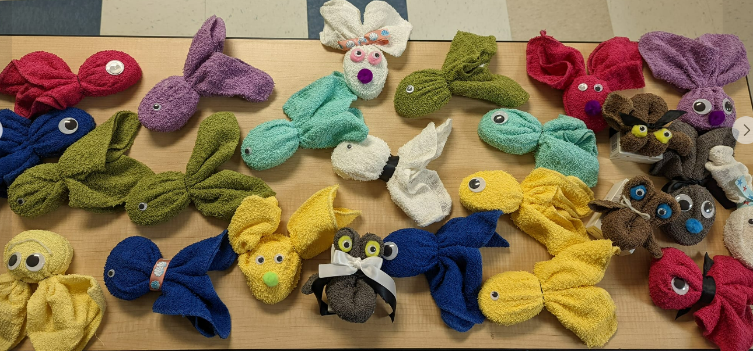
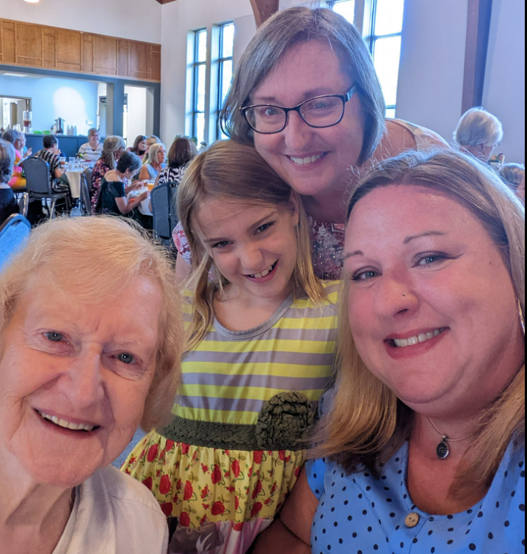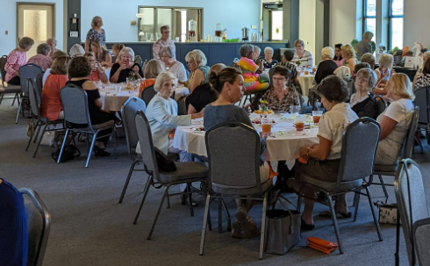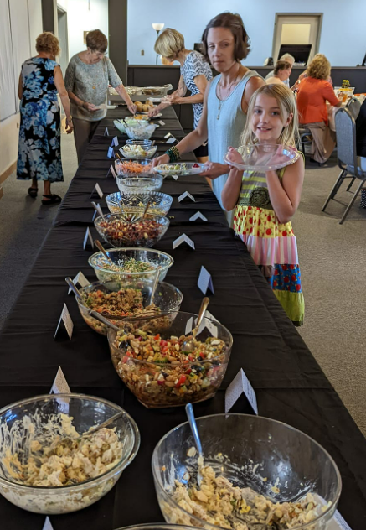

EPSILON SIGMA ALPHA
Southeastern Regional Conference
November 4-5, 2022
ESA MEMBER REGISTRATION

____________________________________________________________________________ ___________
Last Name (Please print) First Name State Council

____________________________________________________________________________________
Address City State/Zip _________________________________________________________________
Telephone # Email Address

Mark All That Apply: (Registration amount is contingent upon approval by SERC board)

_____ Full Member Registration (through 10/7/22) $135.00 $_______
_____ Full Member Registration (after 10/7/22) $150.00 $_______
_____ Full Guest Registration (through 10/7/22) $105.00 $_______
_____ Full Guest Registration (after 10/7/22) $120.00 $_______

TOTAL ENCLOSED $_______
_____________________________________
Guest Full Name
Member Guest
Saturday Entrée Choice: Chicken Marsala with shiitake mushrooms _______ _______
Pan Seared Salmon with lime _______ _______
Medical Dietary Requirements: _______________________________________________________________

Check all that apply:

____ SERC Elected Board ____IC Elected Board ____New Member (pledge)
____ SERC Appointed Board ____IC Appointed Board ____First Time Attendee
____ SERCHETTE ____PICPA ____Other, please specify
____ STATE President ____ESA Foundation Board _________________

Payment Information: *Make check payable to: ESA Sigma Phi and in Comments add SERC Conference 2022
*A $30 fee will be assessed for returned check
*Cancellation must be in writing and received by 10/7/22
*Payment by cash or cashier’s check only after 10/7/22
*A $10 processing fee will be retained on all cancellations
Mail Registration Form and Check to: Joy Lehnert, 14545 Sawgrass Drive, Clermont 34711
Joy.lehnert@yahoo.com 402-690-7720
HOTEL INFORMATION
Renaissance Orlando Airport, a Marriot Hotel, 5455 Forbes Place, Orlando, FL
Room Rate: $129.00 + 12.5% State and Local tax/fees
Reservations: Book the group rate here Telephone: 1-800-619-6720
Event: Epsilon Sigma Alpha/SERC
Free Parking, free shuttle from airport, close to shopping and restaurants
Full American Breakfast coupon can be purchased for $15.00 per day
Website: https://www.marriott.com/orlando
If available, rooms can be booked at the $129.00+ rate before and after convention

FRIDAY GOLF OUTING
Eagle Creek Golf Club
Conveniently located minutes from the Orlando International Airport, Eagle Creek Golf Club Orlando was designed by world-renowned golf course architects Ron Garl and Howard Swan. It is an extraordinary 18-hole, 7200-yard, Par 73 championship course with five sets of tees for golfers of all skill levels and more than 60 bunkers and dramatic bulkheads are reminiscent of those found in Scotland and England. Overall, the true Scottish-style experience of Eagle Creek Golf Club stands out from other Orlando championship golf courses as a true golfing masterpiece!

Proposed green fee—$65.00 which includes cart and warm up range balls. Golf clubs available to rent.
Friday November 4, 2022 9:00 am Transportation can be arranged
Green Fees: $65.00*
*To obtain this rate 16 golfers must participate

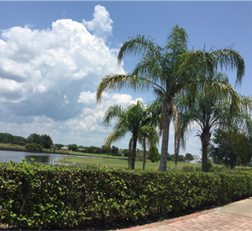
If you or anyone in your group is interested in playing golf on November 4, 2022, please let us know by June 1, 2022.
Please contact any of the individuals listed below to confirm:

Verna Cornell Christine Bishop Joy Lehnert
407-847-3453 407-342-7976 402-690-7720
vcornell1@embarqmail.com cbishop1515@gmail.com joy.lehnert@yahoo.com

SOUTHEASTERN REGIONAL COUNCIL

WILLING TO SERVE FORM

Please type or print on this form.

Yes, I am willing to serve the Southeastern Regional Council (SERC) of ESA in an appointed capacity.

Name _____________________________________ Member #____________________

Address _______________________________ City _________________ State______ Zip _______

Phone: Home __________________Work __________________ Cell ________________________

Email: __________________________________

Chapter Name/Number ______________________________________ State Council _________________

Number of years of ESA service _____

Husband’s name __________________________________________________________________

Give three choices of the committees on which you would like to serve:

(1) ___________________________ (2) _________________________ (3) ________________________

If the above choices were filled, would you be willing to serve in another capacity?
Circle or highlight one: Yes – No

List the offices that you have held and the committees on which you have served.
(If needed, continue on the back.)

Chapter: _________________________________________________________________________

________________________________________________________________________________

State Council: _____________________________________________________________________

________________________________________________________________________________

SERC: ________________________________________________________________________________

________________________________________________________________________________

IC: ________________________________________________________________________________

(Signature of Nominee)
This Form must be postmarked by June 15, 2022 and mailed to the SERC 1st Vice President.

Theda Hall

1st Vice President/President Elect, SERC
thent@aol.com
4400 Tahoe Circle Drive
Springdale, AR 72762-7404

SERC State Dues Form 2021-2022

Date Mailed: ______

State Name: ___________

State President Name: ___________________________________

State President’s Email Address: ___________________________

Treasurer’s Name: ___________________________________

Treasurer’s Address: _______________________________

Treasurer’s Email Address: ________________________

Amount of Dues: $15.00 Amount Enclosed:

Make checks payable to SERC and please mail dues to:

Lauren Ryan
202 Chateau Place Chapel Hill, NC 27516 laurengeryan@gmail.com

For Completion by the SERC Treasurer
Date Received: Check # Date Deposited: Date sent confirmation:

SERC Chapter Donation Form 2021-2022

Date Mailed: __________________

Chapter Name: _________________________

Chapter President Name: __________________

Chapter President’s Email Address:

Treasurer’s Name: ________________________

Treasurer’s Address: ________________________________

Treasurer’s Email Address: ___________________________

Donation Amount Enclosed: ______

Make checks payable to SERC and please mail donations to:

Lauren Ryan
202 Chateau Place
Chapel Hill, NC 27516 laurengeryan@gmail.com

For Completion by the SERC Treasurer
Date Received: Check # Date Deposited: Date sent confirmation:

2022 SERC ASSOCIATION OF THE ARTS ENTRY FORM

Artist’s Name:_________________________________________________________________________________

Address:_______________________________________________________________________________

Chapter Name/No.:_____________________________________________________________________________

Council:______________________________________________________________________________

phone:_________________________________________________________________________________

Email:________________________________________________________________________________

Please check all divisions that you would like to enter. One entry per Division per member.

DIVISION I – PAINTING _________ # of entries
- Oils ______ B. Acrylics_______ C. Watercolors__________
DIVISION II – LITERATURE __________ # of entries

Poetry/Short Story/Humorous Essay – 500 words or less (judged on content originality, form and expression). All literary entries must be typed in double spaces on 8 ½ x 11 paper.

DIVISION III – FIBERS _______ # of entries
- Quilting______ B. Crewel/Embroidery_______ C. Counted Cross Stitch______
D. Knitting_______ E. Needlepoint________ F. Crocheting_______

DIVISION IV – VISUAL ARTS _______ # of entries
Photography – Black and white or color (mounted or framed for display).

DIVISION V – PAINTED ARTS ______ # of entries
- Pottery ________ B. Ceramics ________ C. Porcelain ______ D. China Painting ________
DIVISION VI – HOLIDAY ART _______ # of entries
- Christmas Ornaments (all types) ________ B. Decorations _______
DIVISON VII – WEARABLE ART ______ # of entries
- Sewing _______ B. Fabric Painting ______ C. Jewelry _______
DIVISION VIII – MIXED MEDIA ______ # of entries
- Stamp Art ______ B. Decoupage _______ C. Glass ______ D. Wood ______ E. Other _____
NOTE: When applicable, give background information and/or techniques used to create work of art on an index card.

Check in times will be on FRIDAY, November 4, 2022. Times will be printed in the Conference Program.
Completed form must be postmarked by October 4, 2021, and mailed to:

SERC Association of the Arts Chairman
Anthe Tyndell
16501 Redcliff Drive, Apt 3D
Huntersville, NC 28078
Phone: 910-508-8012 Email: anthe51@gmail.com

Day TRIPS:

Florida has two unique experiences for you to choose from if you would like to participate in the November 4th outing. Both outings will last from 8:30am-3:00pm and some walking is required. You may only choose one outing.

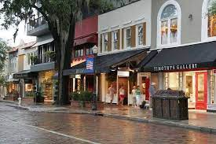
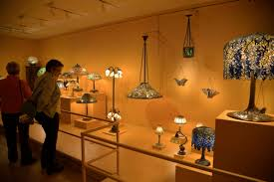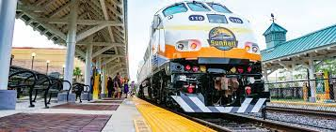

Outing 1 Morse Museum-You will travel north on a double decker train 15 miles to Winter Park. Once you depart the train you will be at Park Avenue. Park Avenue is a tree lined, cobblestoned street with hundreds of specialty shops and award-winning eateries.
The Charles Hosmer Morse Museum is known for its Louis C. Tiffany exhibits and the Tiffany Chapel interior from the 1893 World’s Fair. As you visit this museum; a tour guide will walk you through the various exhibits and show you the vast collection of Louis Tiffany’s glass windows and other artworks. After visiting the museum, you may enjoy lunch on your own at one of the fine restaurants that line Park Avenue. Then, walk a short distance back to the train station to travel back to the hotel. You will need to be at the train station no later than 1:45 pm. The train leaves the Winter Park Station promptly at 2:06pm.
or
Outing 2 Scenic Boat Tour-You will travel by the same train to Winter Park. Once you leave the train station, you will walk 3/10th of a mile to the Famous Winter Park Scenic Boat Tour. While on this narrated one-hour tour, you will cruise through three of the seven lakes and two narrow manmade canals of historic Winter Park. While on this tour, you will see breathtaking views of private homes and estates sprawled along the shores. Also, participants will observe Florida’s wildlife and flourishing subtropical flowers. After the tour, you may have lunch on your own at one of the award-winning eateries and shop the boutiques of Park Avenue. After shopping, you will walk to the train station to travel back to the Sand Lake Station. You will need to be at the train station no later than 1:45 pm. The train leaves promptly at 2:06pm.

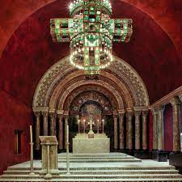
Registration Form
for SERC
November 4, 2022 Outing

Name: ______________________________________________
Address: _____________________________________________
Phone Number (cell)______________________

Select One
Outing 1-Train Ride, Shopping, Museum-$20.00 per person
or
Outing 2-Train Ride, Boat Ride, Shopping-$20.00 per person
----------------------------------------------------------------------------------------
Select Outing-Please indicate the number of people attending the outing you select.
Option 1-Museum ________ Option 2-Boat Ride _________
--------------------------------------------------------------------------------------
If you have guests that are attending, please include them in the numbers above and list the guest names below:
Guest Names: __________________________ __________________________________________________
The cost for each member/guest attending is $20.00 per person.
Checks should be payable to Sigma Phi and postmarked on or before October 10th. and mailed to Karlene Beville, 3707 Bramble Court, Saint Cloud, Florida, 34769.

Outing 1-Museum | Outing 2-Boat Ride
8:30-Meet in Hotel Lobby  Fl. Sisters will transport all to train station.  9:13-Train Departs and travels north to Winter Park  9:39-Arrive in Winter Park  9:39-11:00-Shopping  11:00-12:05-Museum Tour  12:05-1:40-Lunch and More Shopping  1:45-Meet back at train station  2:06-Train Departs Winter Park Station (southbound)  2:33-Back to Sand Lake Train Station  2:33-3:00-Florida sisters transport guests and members back to the hotel.  This is a map of Park Avenue so you can see how close everything is. You will be given a more detailed map on November 4^{th.} Also, there are plenty of benches that line Park Avenue. | 8:30-Meet in Hotel Lobby  Fl. Sisters will transport all to Sand Lake Station  9:13-Train Departs and travels north to Winter Park  9:39-Arrive in Winter Park  9:39-10:45-Shopping  11:00-12:00-Boat Tour  12:00-1:40-Lunch and Shopping  1:45-Meet back at train station  2:06-Train Departs Winter Park Station (southbound)  2:33-Back to Sand Lake Train Station  2:33-3:00-Florida sisters transport guests and members back to the hotel.  These are the shops and eateries that are located around the train station, museum and boat tour.
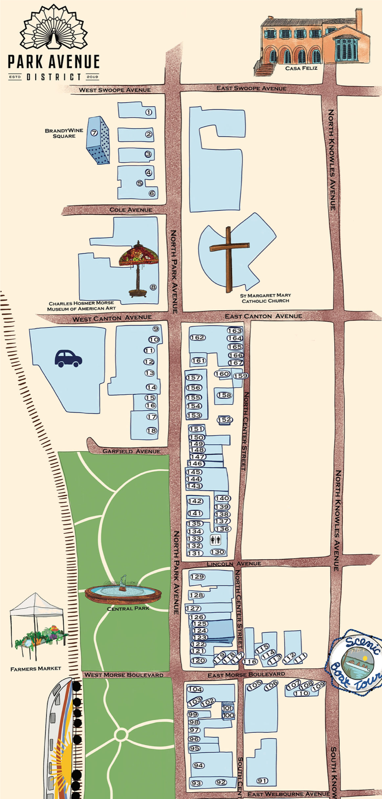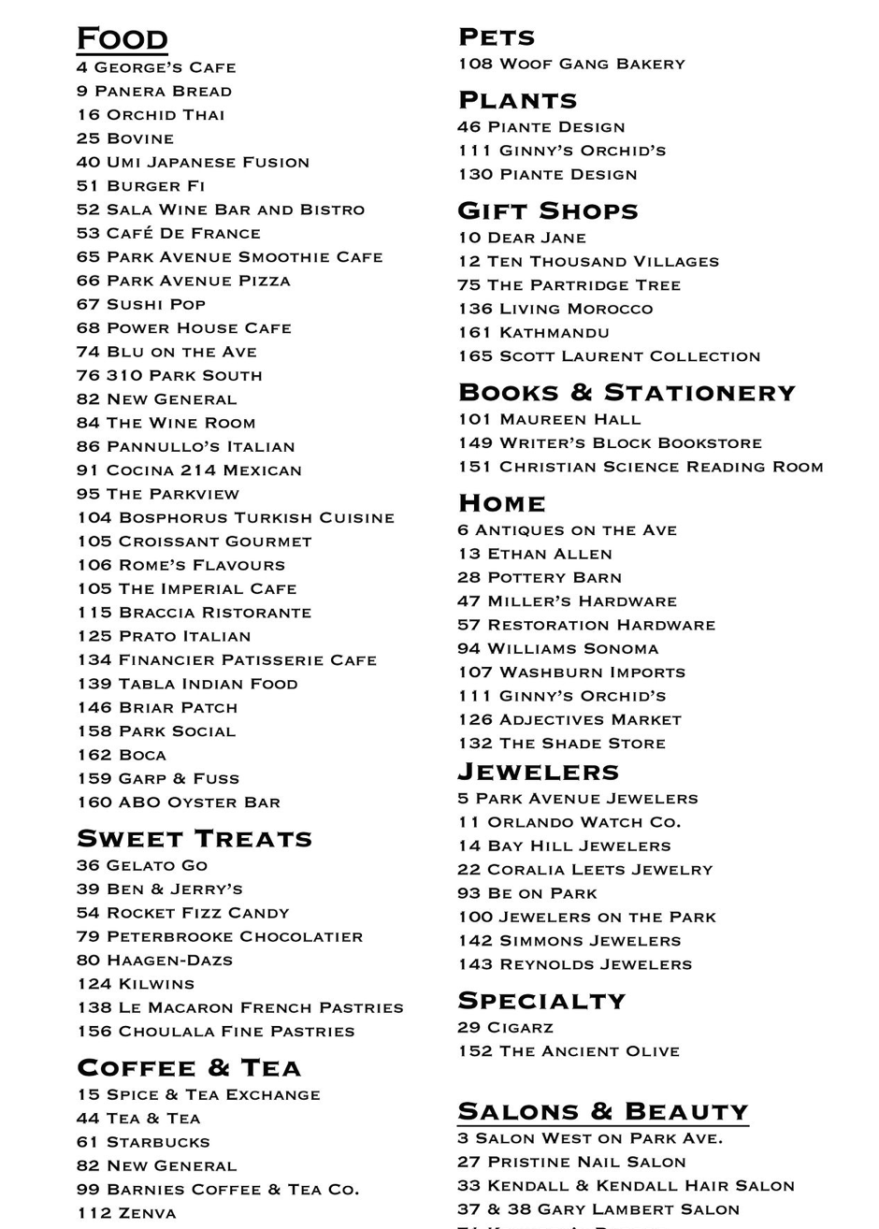
Travel Facts
It is 3/10ths of a mile from Train Station to the Museum.

It is 4/10ths of a mile from Train Station to Scenic Boat Tour.

Morse
Museum

Scenic Boat Tour
Train
Stationn

SERC 2022
Conference At A Glance

Locations for most events are to be announced or published at later date
Schedule is subject to change so check your agenda in the program you receive at registration

Thursday, November 3
Conference Registration
Hotel Lobby
4:00pm-5:30pm

Friday, November 4

Gather for Outings in the Hotel Lobby
8:30 am

Serchettes Meeting
Presidential Suite
9:00 am

Conference Registration
Hotel Lobby
11:00am-5:00pm

Executive Board Meeting
Presidential Suite
10:45am-1:30pm

Association of the Arts
Check in with Anthe Tyndell
2:00pm-4:00pm

Opening Ceremonies
Flag Rehearsal
4:00 pm with Gail Marchant

1st time attendees
4:30 PM

Welcome Party
6:00 pm

Saturday, November 5
Celebration of Life
8:00 am

Seating for Opening
Flag Ceremonies,
Annual Conference Meeting
8:40 am – 11:30 am

Election Results
Presidential Suite
Candidates only
11:45 – 12:15

Awards Luncheon
12:30 pm

Association of the Arts
Viewing
3:00 pm – 4:00 pm

Installation Practice
3:00 pm – 3:30 pm
With Judy Tomlinson

St. Jude Practice
3:30 pm – 3:45 pm
With Anita Hilburn

2022-2023 Executive &
Appointed Boards
Meet with Theda Hall
4:00 pm – 4:30 pm

Association of the Arts
Pick up
4:00 pm

Installation & Banquet
6:00 PM

President’s Reception
Presidential Suite Following the Banquet

Hope to see you in Orlando!
Wanda Ferris, publisher
wlferris@att.net
