“Everything Begins With An Idea”

Betty Boullion

State President

Louisiana State Council

2023-2024

Editor Lois Soileau

LOUISIANA Council of ESA
EXECUTIVE BOARD
2023-2024

Betty Boullion (President) Anita Hilburn ( Parliamentarian)
728 W Gloria Switch Rd. 233 Sugar Creek Loop
Lot 49 Minden, Louisiana 71055
Lafayette, Louisiana 70507-2326 318-773-9228
Cell: 337-230-4296 Email: anita.hilburn@gmail.com
Email: bettyboullion@yahoo.com

Taylor Aucoin (Vice President)
208 Hill Ridge Dr.
Youngsville, Louisiana 70592
Cell: 337-849-1262
Email: taylora@a1professional.org

Wanda Farris (Treasurer)
23095 Arcwood Dr.
Denham Springs, Louisiana 70726-2321
Cell: 334-324-2285
Email: wferris@att.net

Sandra Fontenot (Recording Secretary)
100 Teal Lane Apt. 8
Lafayette, Louisiana 70507-4957
337-849-2190
Email: sandraswine@gmail.com

Anna Lifsey (Corresponding Secretary)
315 Amesbury Rd. Apt. 178
Lafayette, Louisiana 70507
337-344-6043
Email: annajerriel@gmail.com

LOUISIANA COUNCIL OF ESA
2023-2024 APPOINTED BOARD
POSITION | NAME | EMAIL ADDRESS | PHONE
AWARDS | Terri Sayre | tisayre@cox.net | 504-231-9072
BAYOU ANGELS | Anita Kay Hilburn | anita.hilburn@gmail.com | 318-773-9228
BAYOU BANTER EDITOR | Lois Soileau | bayoubanter@yahoo.net | 318-613-0928
CHAPLAIN | Cindy Richard | Cynthiabooullion54@gmail.com | 337-278-0769
DISASTER FUND CHAIR | Mary Jane Easterly | Mje.beast@gmail.com | 318-617-3388
EASTER SEALS CHAIR | Fern Hollis Laing | fphollis@yahoo.com | 318-773-1440
EDUCATION CHAIR | Alice Buss | alicemaraiebuss@gmail.com | 985—856-8371
FOUNDATION CHAIR | Dale Norred | dmnorred@yahoo.com | 985-709-9190
HISTORIAN | n/a
MEDIA SPECIALIST | Taylor Aucion | taylora@aprofessional.org | 337-849-1262
PHILANTHROPIC | Dale Norred | dmnorred@yahoo.com | 985-709-9190
RUSH | Taylor Aucion | taylora@aprofessional.org | 337-849-1262
SERC COUNSELOR | Terri Sayre | tisayre@cox.net | 504-231-9072
SPECIAL PROJECTS | Sallie Rose Hollis | Srh0116@hotmail.com | 318-278-0070
ST. JUDE SENIOR | Beth Fife | Bfife02@gmail.com | 318-224-3270
ST. JUDE JUNIOR | Lester Fife | Lfife2008@gmail.com | 318-594-2694
WAYS AND MEANS | Holly Champagne | hollister415@hotmail.com | 985-856-8371
WEBSITE | Anita Kay Hilburn | anita.hilburn@gmail.com | 318-773-9228
WORKSHOP | Anna Lifsey | annajerriel@gmail.com | 337-298-9072

Welcome to Fall Council 2023

As your president, I am looking forward to seeing all of you again. It seems like just yesterday we were at State Convention.
A lot has happened since convention. I have been busy working on the State President Book and I have been to International Concil in Grapevine. More on this at Fall Council.
I have lots of good news and a lot of new things to tell you about.
I am excited to be back at Southern Creations meeting place. Thank you Alpha Alpha.
I hope to start our Board Meeting at 9:am with our general membership meeting to follow at 10: am.
Welcome to you all and I am looking forward to seeing everyone again.
Betty Boullion
President
337-230- 4296
bettyboullion@yahoo.com
From Wanda Ferris: Treasurer
Hello from Idaho! Sorry your summer is not as cool as mine. Everyone take care in this heat!
Wanted to remind all Chapters to turn in your Tax report to IC by mid-August! This is important for our continued non-profit status.
Also, forms are available online to pay your state dues by October. Send them to my address in Idaho please.
Wanda Farris
601 MCGHEE Ct.
Sandpoint, ID 83864
See you next year at Convention!
Louisiana State Council of ESA Host Chapter post annual Convention Financial Report

Dates of Convention: June 2-4,2023_____ Host Chapter Name: Alpha D elta__________
Income:

Number of LSC members Registered: _35_______
Number of others registered: ___2___________
Total income from Registration: _$ 4,140__________________
Total income from Ways and Means Projects: __$ 425________
Other income: _$ 600 for Sponsorship___
Explain other: ___________________________________________________________
Total income: $ 5,165.00 _
Expenses:

Cost of Room rent: ___$ 400________
Cost of Food: $ 3,393.41_____________
Cost of any equipment: ___n/a_________
Explain what was rented: ______________________
Any other Cost: _$1,111.34__________
Explain: __$ 125 registration:
$ 212.5 State ways /and means basker raffle
$ 648.84 decorations and ditty bags
$ 125 return registration_________
Total Expenses: _$ 4,984.75___________ Profit or loss (circle one): +$ 260.25__________

Beth Fife St Jude Senior Chair
Lester Fife St. Jude Junior Chair
In 1972, ESA officially recognized St. Jude Children’s Research Hospital – the largest center for treatment and research of pediatric cancer and other childhood catastrophic diseases in the U.S. – as a national project. As a result of ESA member’s enthusiastic response to a heartfelt personal appeal by the hospital’s founder Danny Thomas, the hospital became ESA member's first internationally supported charity.
Thousands of children each year are treated at the hospital regardless of their ability to pay. Through public contributions, the hospital covers all medical costs not covered by insurance, and covers all costs for families without insurance.
Louisiana has an amazing record of raising funds for St. Jude Children’s Research Hospital. At this year’s IC convention, we received the Danny’s Dream Award for raising 48 million dollars overall so far. We received the Pinnacle Award for raising more than a million dollars in the year. Louisiana came in first this year by raising $2, 892,909 for St. Jude. Kudos to everyone for a job well done. Omega Tau got a third-place chapter for raising money on a non-dream home or radiothon event. Louisiana came in first for amount of money per member raised which was 28,643 per member.
Just a reminder that to get credit for any St. Jude event you must fill out the Completed Event Form that is on the ESA website. Once you go to the Member Center click on chapter/council and there is a heading for forms then click on St Jude Forms. There you will find an online one you can fill in and it is automatically sent to IC. There is also a PDF form available. IC Headquarters is requesting that all fill out the forms online for their events. Also reading directions, IC would like to know the total number of hours spent on the project which you can add to the form even though there is not a place for that on the form.
If you have friends that give donations, you could give them a donation form with your chapter name and number on it and request they send it in to IC Headquarters. That way your chapter will get that credit. There is also information about how to do online fundraisers..
​Online Fundraisers: Submit a completed event form above and be sure to add in the comment section any details about your event (i.e., what platform you used for your fundraiser, your fundraising link).
- First, always try to set up a YourWay page at stjude.org/YourWay and include ESA in your event name. You will be able to create a FaceBook fundraiser through your YourWay dashboard. You will not need to send an additional screenshot if you created your fundraiser this way.
- If you created an online fundraiser through Facebook directly, screenshot your page, total raised, and email to esaforstjude@epsilonsigmaamlpha.org so we can confirm the amount.

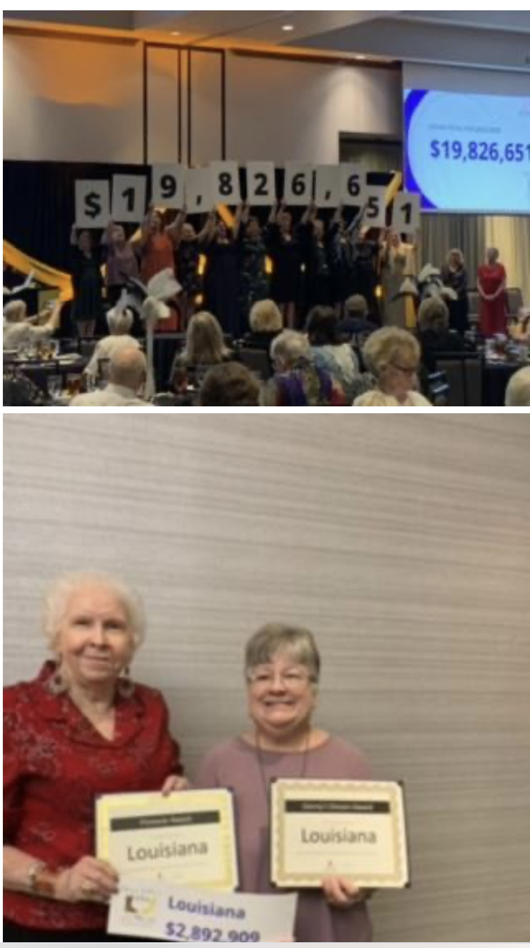

Zeta Rho News

Zeta Rho's summer has been filled with activity and accomplishments. At the top of the list: We successfully finished up the Monroe St. Jude Dream Home project, and several of our members now have multiple conventions under their belts.

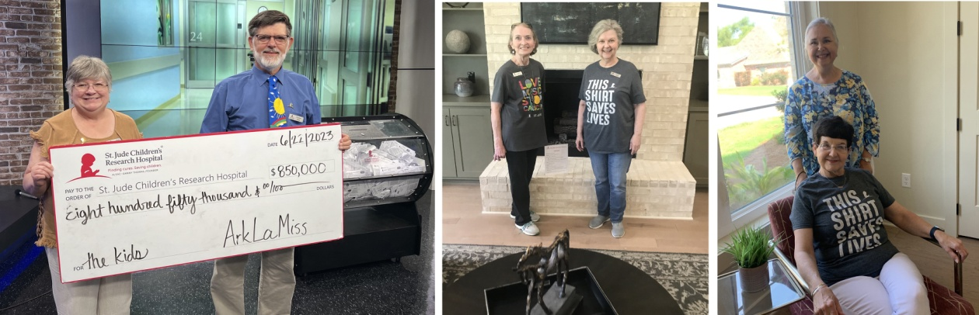

In photo above: (left) Beth and Lester Fife display the $850,000 check during the live drawing for the Monroe Dream Home on KTVE-KARD TV; they served as co-chairs of the event. Other Zeta Rho members also had the opportunity to host during the Open House, along with community volunteers. Shown here (from left) are Cherri Barmore, Sallie Rose Hollis, Jennifer Patterson and Norlyn Hyde.

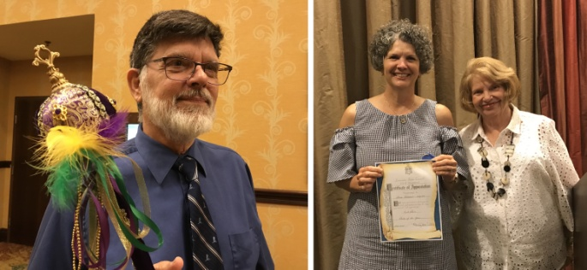

At our Louisiana ESA Convention this summer, Zeta Rho was excited that two of our members claimed top honors. Lester Fife (left), 2023 Member of the Year, dutifully posed for a photo op with his scepter in the hall after the convention. In the right photo, Gina Holstead holds her first-place certificate for Pledge of the Year. Congratulations, Lester and Gina!

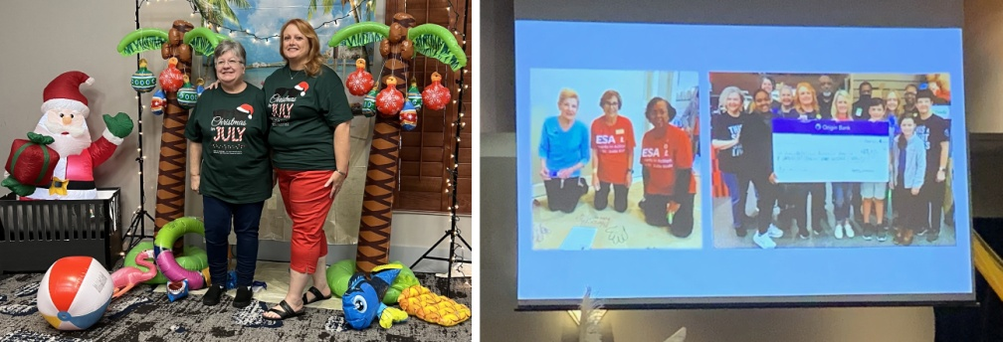

Veteran members Beth Fife and Nancy Darland (above, left) attended IC convention, where they were pleased to see that Zeta Rho's 2023 Radiothon made the St. Jude staff presentation at the banquet.

EASTER SEAL REPORT

ESA Easter Seals Report for the State of Louisiana

Beta Gamma Donated $ 25.00

Alpha Delta Donated $ 100.00

Omega Tau Donated $ 50.00

Zeta Rho Donated $ 100.00
Total $ 275.00

Alpha Alpha has been busy since our last newsletter. We did a plant sale in March. This has been a special event that we have done over twenty-five years. We made over $ 7,000.00 for the kids. Our best year so far.

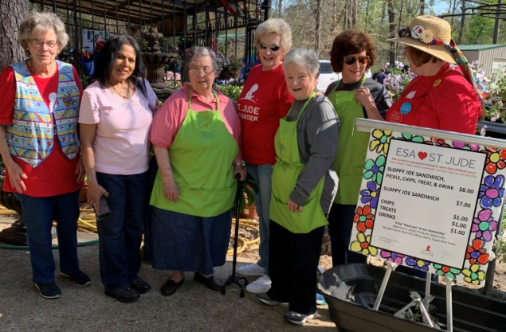

We also did for the second year a Boston Butt sale. This year we added hams and cakes to the event which was very successful. We sold out of everything.

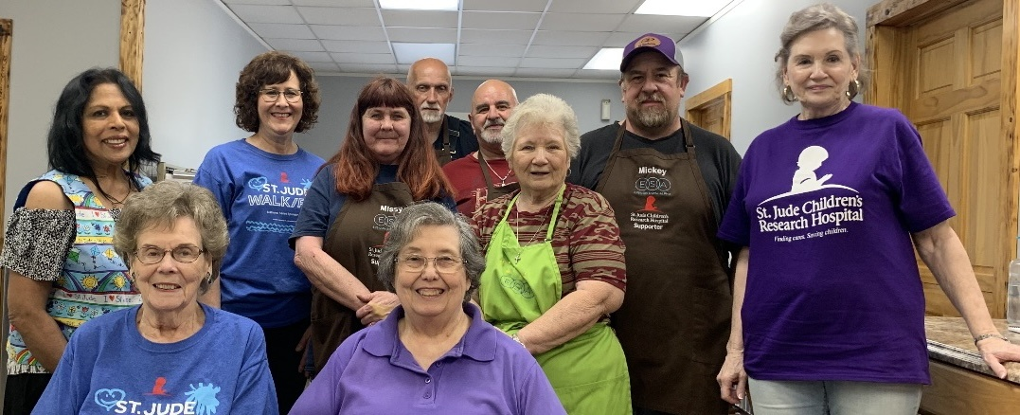

And we also worked the Baton Rouge Dream Home. We got off to a slow start but we were able to work the open house.

This August we will be doing a Pledge Ceremony and a Jewel Pin ceremony for our two newest members.

Plans are in the works for Fall Council. Hope to see a lot of members join us for the day. Send in your registration as soon as possible.

LOUISIANA STARE COUNCIL AWARD WINNERS

Betty Hawthorn Philanthropic Monies Award
3rd Place: Zeta Rho $ 47,383.57 per member
2nd Place: Alpha Delta $ 68,673.09 per member
1st Place: Alpha Omega $ 153,327.14 per member

Dale Norred Philanthropic Hours Award
3rd Place: Alpha Delta 98.37 per member
2nd Place: Alpha Omega 106.96 per member
1st Place: Zeta Rho 191.37 per member

Rose Ann Mire Disaster Fund Award
3rd Place: Alpha Omega $14.29 per member
2nd Place: Beta Gamma $25.00 per member
1sr Place: Alpha Alpha $56.25 per member

Eloise Collins Educational Award
3rd Place: Alpha Alpha
2nd Place: Zeta Rho
1sr Place: Beta Gamma

Iris Carter Rush Award
3rd Place: Zeta Rho
2nd Place: Alpha Delta
1st Place: Alpha Alpha

Betty Cadwell Pledge of the Year
3rd Place:_______________
2nd Place:_______________
1st Place: Gina Holstead----Zeta Rho

Becky Roger Member of the Year
3rd Place: Cary Haro---Beta Gamma
2nd Place: Pat Thibodeaux-----Alpha Omega
1st Place: Lester Fife----Zeta Rho

Tommy Hebert Chapter of the Year Award
3rd Place: Beta Gamma
2nd Place: Zeta Rho
1st Place: Alpha Alpha

St. Jude Totals for 2022-23

Alpha Gamma $ 50.00
Louisiana State $ 200.00
Mal $ 300.00
Omega Tau $ 151,340.00
Beta Gamma $ 210,254.00
Alpha Alpha $ 275,427.25
Zeta Rho $ 482,780.00
Alpha Delta $ 777,812.44
Alpha Omega $ 1,065,168.50
Total $ 2,963,332.19

LOUISIANA STATE CONVENTION/ FALL COUNCIL 2023
SEPTEMBER 9, 2023
“Fall Council on the Red-Where new Ideas flow into ESA Dreams”
SOUTHERN CREATION
208 Main Street
PINEVILLE, LOUISIANA

ESA MEMBER REGISTRATION
Last name_________________________FirstName_________________________
Address______________________________State____
Telephone_________________________GUEST NAME_____________________
MARK ALL THAT APPLY:_____
Full Member Registration ( thru 9/1/20) $ 30.00__________
_____Guest Registration (9/1/20) $ 30.00__________
_____Late Registration $ 35.00_________
SPECIAL DIETARY NEEDS
__________________________________________________________________
CHECK ALL THAT APPLY
___State Board ____Appointed Board ___Past State President ____Chapter President
___First Time Attendees ___ Pledge ___IC Elected and General Board
___SERC Elected and General Board
MAKE CHECKS TO ALPHA ALPHA #0880 (No EXTRA meals will be ordered unless paid for in advance.)
MAIL TO:
Lois Soileau
5956 Dixie Lane
Alexandria, La. 71301

